Appendix 1: additional details on effect size calculations
The standardized mean change was calculated for each group as follows:
$$d=c\left(n-1\right)\frac{{\overline{X}}_{pre}-{\overline{X}}_{post}}{S_{pre}}$$
where ${\overline{X}}_{pre}$ and ${\overline{X}}_{post}$ are the mean scores before and after intervention, $S_{pre}$ is the standard deviation of the pre-test scores, and $c\left(n-1\right)$ is the small-sample adjustment given by:
$$c\left(n-1\right)=1-\frac{3}{4\left(n-1\right)-1}$$
with n representing the group size. The sampling variance for d was computed using the following expression:
$$V_{d}={⌊c(n-1)⌋}^{2}⌊\frac{2(1-r)}{n}⌋\left(\frac{n-1}{n-3}\right)\left(1+\frac{nd^{2}}{2(1-r)}\right)-d^{2}$$
where r is the correlation between the scores at both time points. Since the primary studies included in this review did not report r, we imputed it for each variable using raw data available from one of the included studies (Quiles et al., 2018). For variables where this information was not available (e.g., outcomes not measured in Quiles et al., 2018), we imputed a value of 0.7.
The effect measure for group comparisons was the difference in standardized mean changes calculated as:
$$d_{g}=d_{E}-d_{C}$$
where $d_{E}$ and $d_{C}$ are the standardized mean changes for the experimental and control group, respectively, as defined above. The sampling variance for $d_{g}$ was computed as the sum of the sampling variance of $d_{E}$ and $d_{C}$:
$$V_{d_{g}}=V_{d_{E}}+V_{d_{C}}$$
An exception was patient BMI, for which we used the raw mean change difference, calculated as:
$$D=({\overline{X}}_{pre,E}-{\overline{X}}_{post, E})-{\overline{X}}_{pre,C}-{\overline{X}}_{post,C })$$
whereas the sampling variance for D was computed using the expression:
$$V_{D}=\frac{S_{pre,E}^{2}}{n_{E}}+\frac{S_{pre,C}^{2}}{n_{C}}$$

Appendix 2: Supplementary figures

Figure A1
Forest plot for BMI, symptomatology and emotional well-being in patients: changes from baseline to follow-up
BMI
Symptomatology
Emotional well-being

Figure A2
Forest plot emotional well-being, accommodation and expressed emotion in carers: changes from baseline to follow-up
Emotional well-being
Accommodation
Expressed Emotion

Figure A3
Heterogeneity in carers’ emotional well-being: forest plots
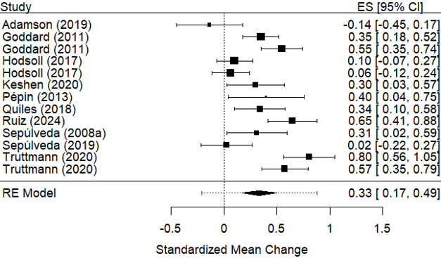 | 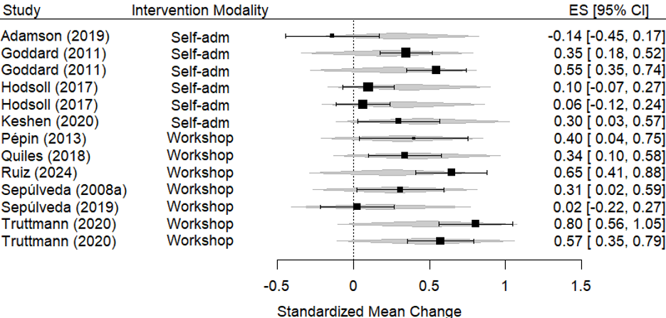
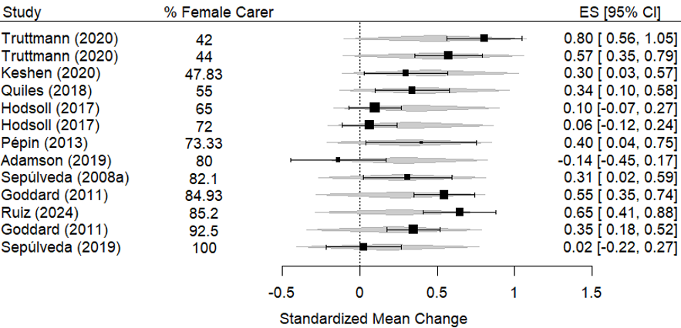 | 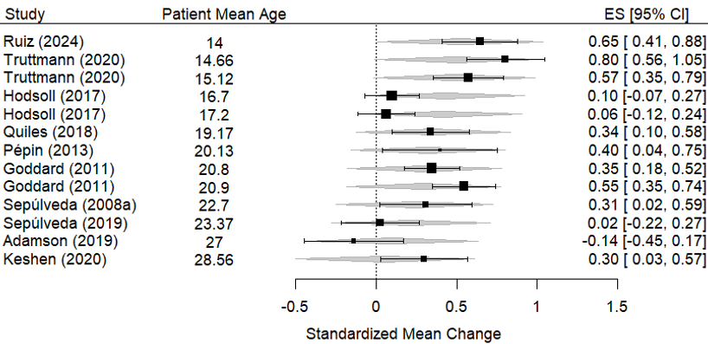

Figure A4
Heterogeneity in carers’ accommodation: forest plots
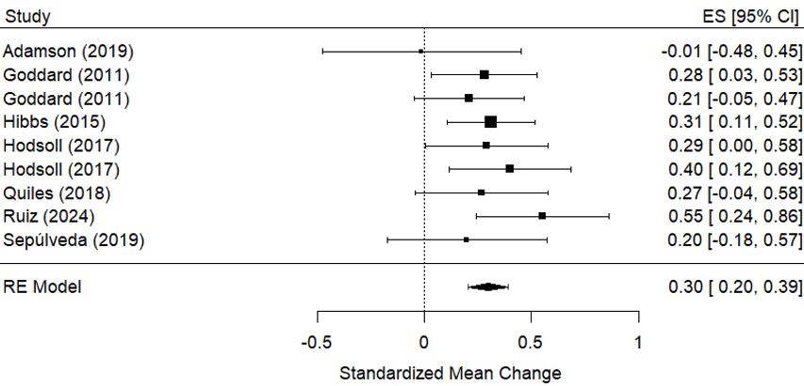 | 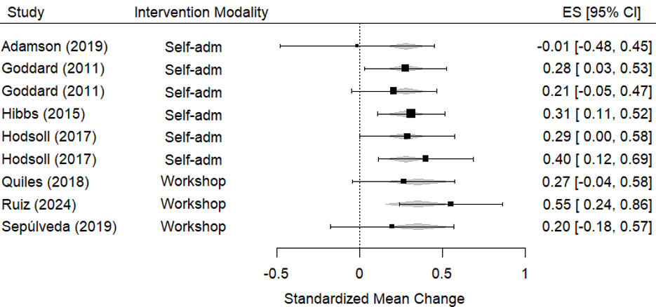
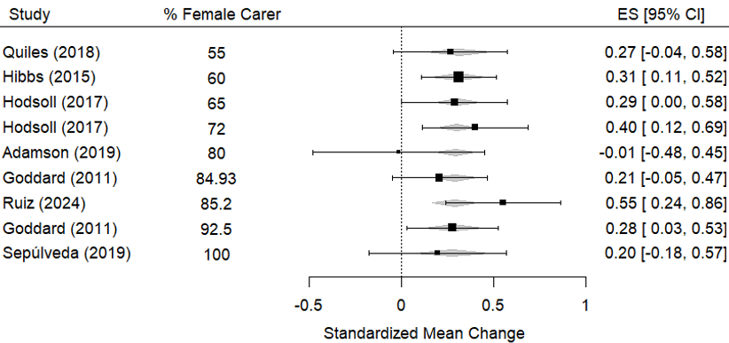 | 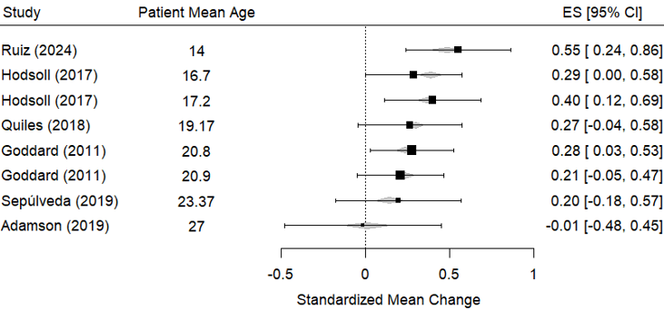

Figure A5
Heterogeneity in care skills: forest plots
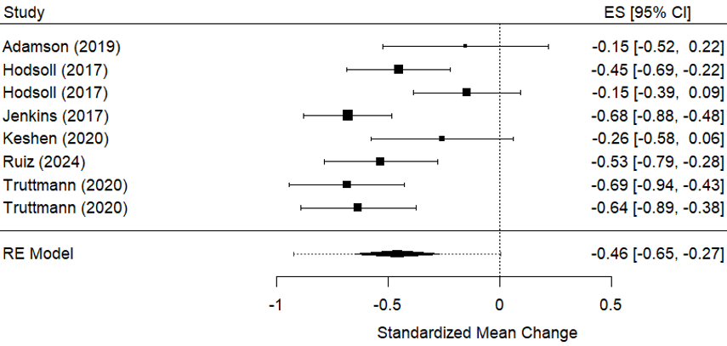 | 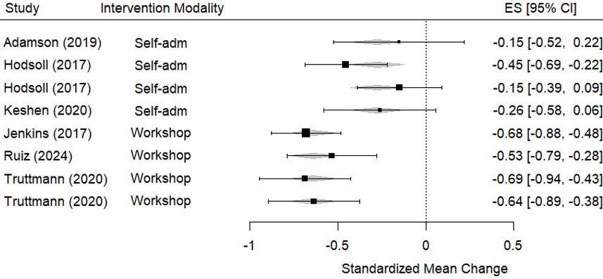
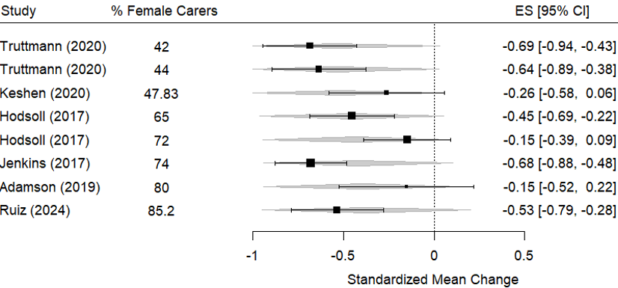 | 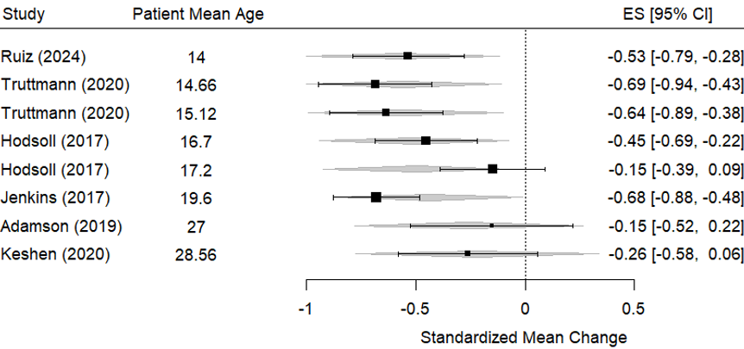

Figure A6
Heterogeneity in expressed emotion: forest plots
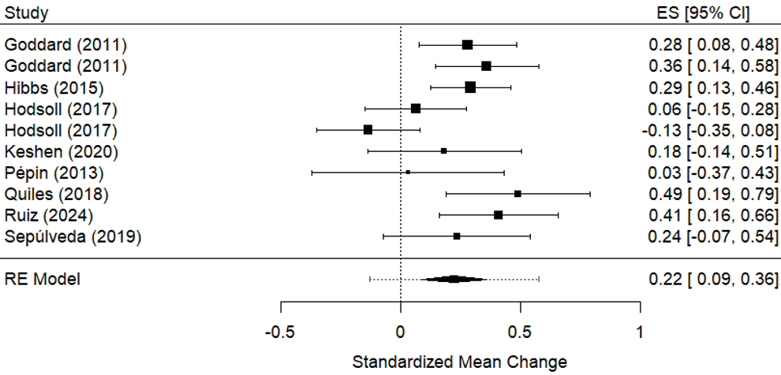 | 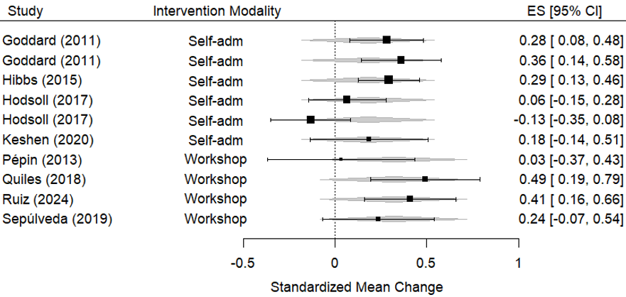
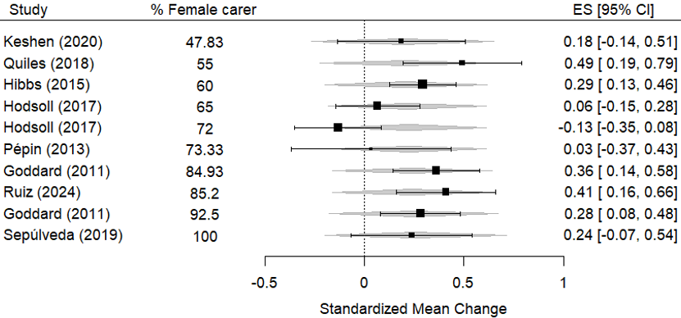 | 