Supplementary data

Supplementary Table 1. Actual time since last visit.
 | Scheduled visit
 | 3 months | 6 months | 12 months
Actual time since last visit  Mean, months  Median, months (range) | 2.95  2.99 (2.5–3.14) | 3.2  3.14 (2.99–3.45) | 5.95  6.02 (4.01–7.99)

Supplementary Table 2. CNB dosage according to responder status of patients at 3- and 6-month visits.
 | 100%  reduction | ≥90%  reduction | ≥75%  reduction | ≥50%  reduction
3 months
Non-responders  Mean dosage, mg (SD)  Median dosage, mg (min, max) | 120.6 (58.2)  100 (12.5, 300) | 119.9 (58.0)  100 (12.5, 300) | 117.3 (57.4)  100 (12.5, 300) | 115.1 (57.5)  100 (12.5, 300)
Responders  Mean dosage, mg (SD)  Median dosage, mg (min, max) | 125.6 (54.6)  100 (25, 200) | 127.4 (56.4)  100 (25, 250) | 130.8 (57.5)  100 (25, 250) | 127.9 (57.3)  100 (12.5, 250)
p-value* | NS | NS | 0.025 | 0.014
6 months
Non-responders  Mean dosage, mg (SD)  Median dosage, mg (min, max) | 176.7 (72.9)  200 (25, 400) | 176.7 (72.9)  200 (25, 400) | 174.2 (72.3)  200 (25, 400) | 174.9 (71.5)  200 (25, 400)
Responders  Mean dosage, mg (SD)  Median dosage, mg (min, max) | 162.8 (56.5)  200 (50, 300) | 167.3 (65.7)  200 (25, 400) | 173.0 (66.5)  200 (25, 400) | 172.9 (68.9)  200 (25, 400)
p-value* | NS | NS | NS | NS
*Mann-Whitney test.
NS, not significant; SD, standard deviation.

Supplementary Table 3. Most frequent adverse events at 0–12 months according to the number of prior ASMs
 | Number of prior ASMs |  |  |  |  | Total (n=486)
AEs*, n (%) | 2  (n=40) | 3  (n=87) | 4  (n=113) | 5  (n=132) | 6  (n=114) | Total (n=486)
Somnolence | 10 (25.0) | 27 (31.0) | 29 (25.7) | 48 (36.4) | 43 (37.7) | 157 (32.3)
Dizziness | 6 (15.0) | 16 (18.4) | 21 (18.6) | 31 (23.5) | 17 (14.9) | 91 (18.7)
Cognitive slowness | 1 (2.5) | 9 (10.3) | 7 (6.2) | 4 (3.0) | 7 (6.1) | 28 (5.8)
Fatigue | 2 (5.0) | 1 (1.1) | 9 (8.0) | 6 (4.5) | 6 (5.3) | 24 (4.9)
Headache | 2 (5.0) | 3 (3.4) | 5 (4.4) | 10 (7.6) | 4 (3.5) | 24 (4.9)
Unsteadiness | 0 (0) | 2 (2.3) | 7 (6.2) | 5 (3.8) | 10 (8.8) | 24 (4.9)
Sedation | 1 (2.5) | 1 (1.1) | 2 (1.8) | 5 (3.8) | 3 (2.6) | 12 (2.5)
Diplopia | 1 (2.5) | 0 (0) | 5 (4.4) | 1 (0.8) | 4 (3.5) | 11 (2.3)
Gait disturbances | 1 (2.5) | 1 (1.1) | 2 (1.8) | 4 (3.0) | 2 (1.8) | 10 (2.1)
Ataxia | 0 (0) | 1 (1.1) | 1 (0.9) | 5 (3.8) | 2 (1.8) | 9 (1.9)
Nausea | 1 (2.5) | 1 (1.1) | 0 (0) | 5 (3.8) | 2 (1.8) | 9 (1.9)
Skin disturbance | 3 (7.5) | 1 (1.1) | 1 (0.9) | 1 (0.8) | 2 (1.8) | 8 (1.6)
Blurred vision | 0 (0) | 1 (1.1) | 2 (1.8) | 1 (0.8) | 2 (1.8) | 6 (1.2)
Celotype | 0 (0) | 1 (1.1) | 1 (0.9) | 2 (1.5) | 1 (0.9) | 5 (1.0)
Dysarthria | 0 (0) | 1 (1.1) | 2 (1.8) | 2 (1.5) | 0 (0) | 5 (1.0)
Irritability | 0 (0) | 1 (1.1) | 0 (0) | 2 (1.5) | 2 (1.8) | 5 (1.0)
Tremor | 0 (0) | 0 (0) | 0 (0) | 1 (0.8) | 4 (3.5) | 5 (1.0)
AEs, adverse events; ASMs, antiseizure medications.
*Only includes AEs occurring in ≥1% of patients overall.

Supplementary Figure 1: (A) Patient disposition and (B) cenobamate treatment retention time (Kaplan-Meier analysis).
(A)
Baseline
n=486
3-month visit
n=474 (97.5%)
Discontinuations, n=12
Lack of efficacy, n=3
Adverse event, n=7
Both, n=1
ªOther, n=1
6-month visit
n=462 (95.1%)
12-month visit
n=447 (92%)
Discontinuations, n=15
Lack of efficacy, n=4
Adverse event, n=4
Both, n=4
^{c}Other, n=3
Discontinuations, n=12
Lack of efficacy, n=2
Adverse event, n=4
Both, n=4
^{b}Other, n=2
ªPatient’s decision (n=1); ^{b}Patient’s decision (n=2); ^{c}Pregnancy (n=1); hospital admission (n=1); other (n=1).
(B)
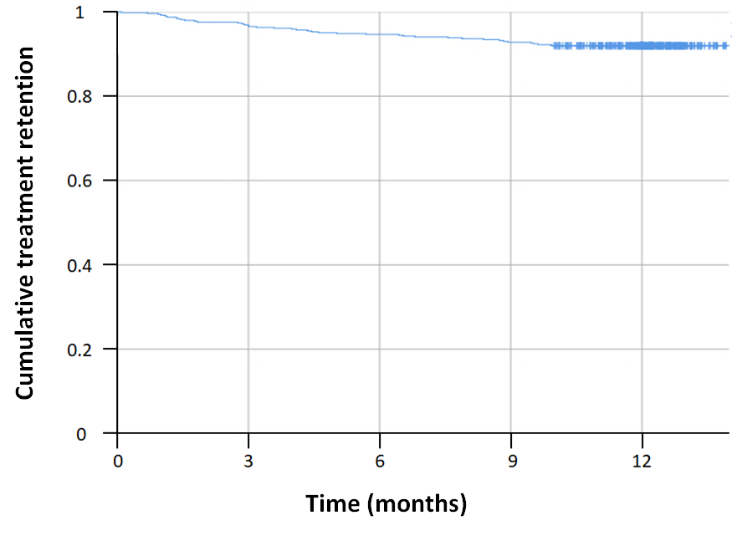

Supplementary Figure 2. Cenobamate treatment retention according to the number of prior ASMs (Kaplan-Meier analysis). (A) by 2, 3, 4, 5 or 6 prior ASMs; (B) by early (2–3 prior ASMs) or late (4–6 prior ASMs) cenobamate treatment line.
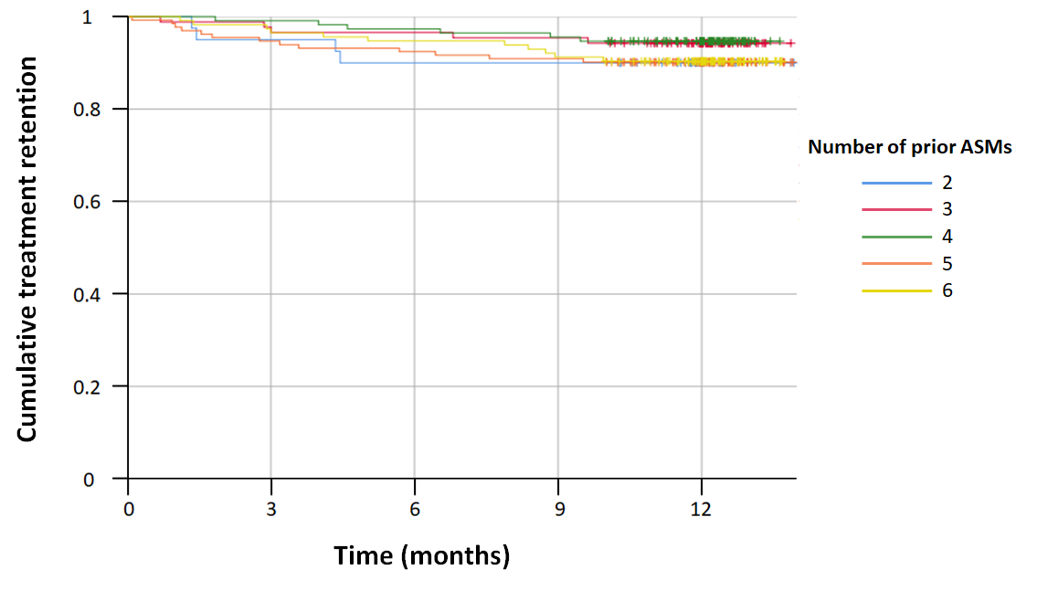
(A)
(B)
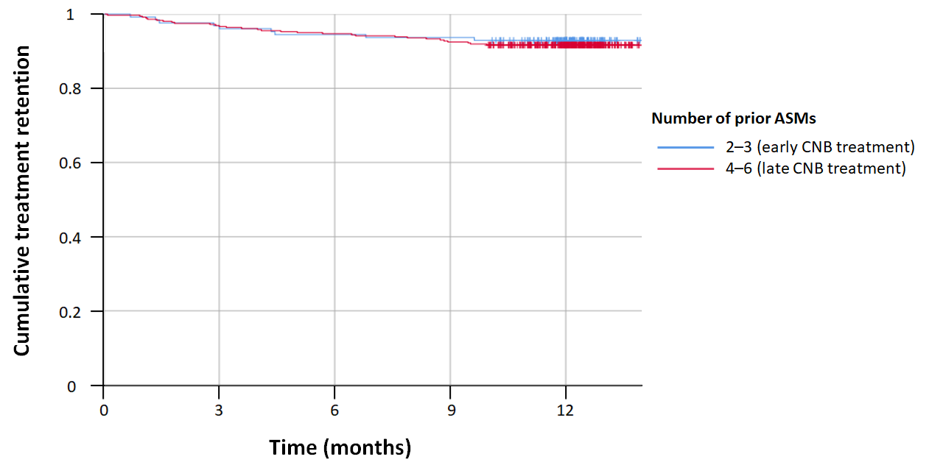
ASMs, antiseizure medications; CNB, cenobamate.

